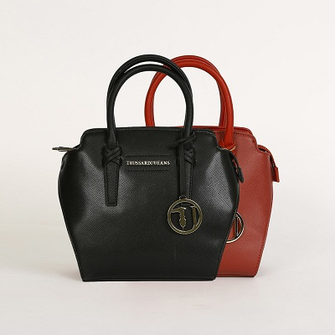

MONTBLANC Small Tote Ecoleather – TRUSSARDI JEANS

PRODUCT DETAILS

**Color: Black, Blue,**

**Bordeaux,**

**Size: 9" L, 5" W, 9" H**